JOB DESCRIPTION
Job Title: | Academic Development Administrator
Department: | Whanake Ake (Academic Development & Quality)
Reports To: | Head of Academic Development & Quality
Job Purpose: | The purpose of this role is to provide administrative services to the Academic Development and Quality team and to administer academic processes across the institute as required.  More specifically the Academic Development Administrator will:  - Provide timely and accurate administrative support and services to the Quality and Programme Development team members following priorities planned with the Head of Academic Development and Quality.  - Manage the Tech1 finance system to meet purchasing requirements of the wider Whanake Ake team.  - Coordinate meetings, workshops and other events.  - Support with the development and production of quality process documentation  - Maintain systems to support continuous quality improvement.
Date: | December 2024

Organisational Context:
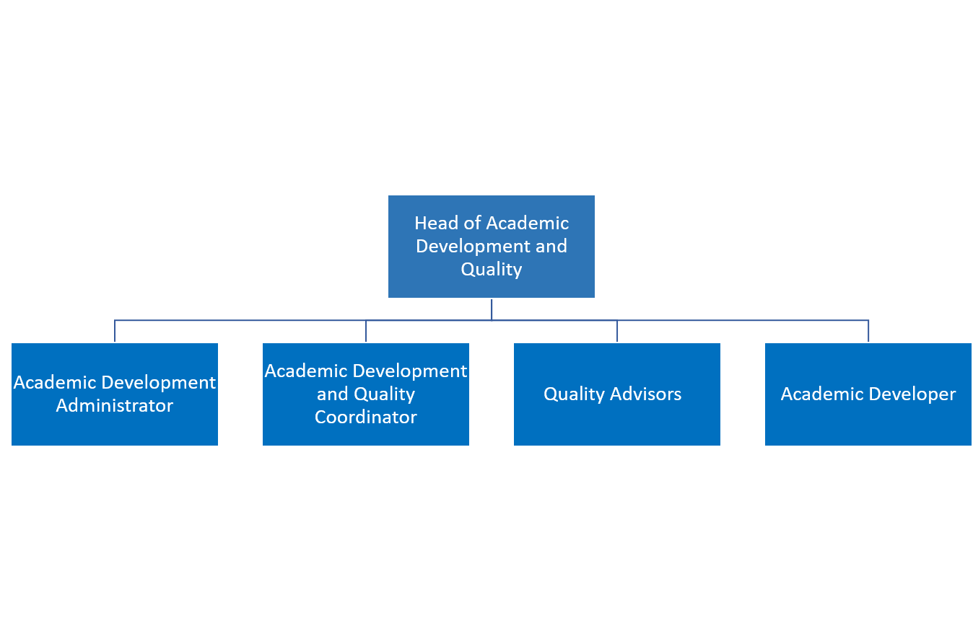

Toi Ohomaitanga: how we act and behave at Toi Ohomai will be guided by our values


Toi Ohomai Institute of Technology Strategic Intent
Globally education is undergoing disruptive change, driven by technology; learner expectations of employment outcomes; as well as employer & government expectations of relevance and value. Delivery models have changed more in the past 10 years than in the previous 1000 years and are expected to change even more rapidly. In this context Toi Ohomai will systematically and continuously adapt to ensure that its education models and practices are relevant; that our technology, systems and processes meets future business needs; that staff capability and culture embraces change; and our physical asset base meets future learning needs, with a specific focus on improving access to education and enabling employment opportunities throughout the Bay of Plenty.

The ability for Toi Ohomai to produce the best possible outcomes for our students, communities and business through seamless connectivity with our regional stakeholders, and Iwi in particular, is critical to the social, cultural, environmental and economic wellbeing of the wider Bay of Plenty region.
Toi Ohomai’s Strategic Intent is to: | We will:
- Have meaningful and effective partnerships | - Be a strategic education partner to Iwi, industry and the communities in the region.  - Recognise Iwi of the region as rights holders.  - Work collaboratively with other education providers.  - Work closely with government agencies.
- Deliver tertiary education, research and technology transfer to meet the needs of the region. | - Ensure that we understand and meet the tertiary education needs of the region.  - Provide accessible and adaptable pathways for learners.  - Develop our discipline and research strengths to align with those of the region.  - Be active in technology transfer and applied research for industry.
- Be innovative and support innovation | - Create an organisational culture that encourages and supports innovative practice.  - Develop activities that support new innovators and entrepreneurs in our region.  - Embrace and share new technologies and practices in education and industry.  - Build our capability and delivery of STEM subjects and courses.
- Be learner-centred | - Offer a range of services to support student success prior to enrolment, during their study and beyond graduation.  - Tailor our educational delivery to suit the needs of the learners and to enhance their employability.  - Ensure our campuses, programmes, delivery and support mechanisms engage and support Maori and Pasifika students to achieve success.  - Create a culturally-safe environment for all learners.
- Be a sustainable organisation | - Ensure that we are financially responsible and sustainable.  - Develop revenue streams appropriate to our core purpose.  - Maintain the highest standards of health and safety for our staff and students.  - Develop the capability of our staff to meet the future needs of the organisation.  - Minimise our negative environmental impact.  - Contribute to the social cohesion of our communities.

Resource Management:
Financial Authorities: | Staff Authorities:
Budget owner: No  Delegated Financial Authority as per Toi Ohomai Delegations Policy: No | Number of Direct Reports: Nil  Number of Indirect Reports: Nil  Responsible for contract staff, and/or coaching, training of others: No  Responsible for new employee hire: No

Functional Relationships:
INTERNAL  - Academic (Whanake Ake) team  - Programme kaiako  - Programme leaders  - Academic Services  - Ākonga/Faculty administration staff  - All kaimahi (as required): to liaise and establish mutually beneficial relationships | EXTERNAL  - Other Te Pūkenga Business Divisions

Key Competencies are framed by Toi Ohomai’s Strategic Intent
The delivery of all key competencies should align to the delivery of the Toi Ohomai Strategic Intent and values. The following list articulates the generic key responsibilities of the role. In addition to these the employee may also be required to undertake reasonable tasks and projects beyond these responsibilities.
Key Competencies: | Expected Outcomes:
Provision of administrative support – Academic Development & Quality  - Provide administrative services to the Academic Development & Quality team following priorities planned with the Head of Academic Development and Quality.  - Manage Tech1 finance system to meet purchasing requirements of the Academic Development (Whanake Ake) Team.  - Coordinate meetings and events, management of agendas/minutes to support engagement between Academic Development & Quality staff and key stakeholders.  - Support with the development and production of quality process documentation.  - Maintain systems to support quality assurance.  - Coordinate the wider Academic Development (Whanake Ake) meetings and take minutes for these meetings. | - Correspondence, documentation, advice and coordination is accurate and timely.  - Records are maintained and regularly updated.
Administration of academic processes  - Provide coordination across the institute between the Academic teams and the Academic Development staff.  - Support development and maintenance of quality improvement activities.  - Assist in reviewing quality processes and associated guidelines and supporting documentation (policies, processes, workflow diagrams). | - Academic processes are administered in an accurate and timely way.  - Improvements to systems are identified and discussed.  - Databases and systems are accurately maintained.  - Professional development is undertaken that maintains currency of practice appropriate to the role.
Applying a continuous quality improvement approach to administrative activities  - Build and maintain relationships with key stakeholders across the institute.  - Ability to work in a culturally competent way with all stakeholders.  - Actively contribute to a culture of quality, sustainability and continuous improvement. | - Positive relationships are built and maintained.  - Follow up actions are undertaken and closed off within the required deadlines.  - Support of team actions for improvement to enable implementation with regular monitoring of progress and outcome.  - Regular engagement in self-assessment and reflection.
Note:
The above key competencies and outcomes are provided as a guide. You are expected in your role to undertake any and all reasonable and lawful instructions and / or delegated tasks given by your manager, or someone in a position authorised to give such instruction. The precise performance measures for this position should be discussed between the jobholder and manager as part of the performance development process.

Person Specification:
Qualifications
Essential: | Desirable:
- A tertiary qualification at minimum level 4 Certificate in relevant discipline. | - Diploma in Business.
Knowledge / Experience
Essential: | Desirable:
- Minimum three years’ experience in an administrative/coordinator/PA role.  - Superior administration skills including the use of SharePoint/TEAMs and Microsoft 365 applications (including Visio).  - Knowledge of academic administration processes.  - Demonstrated ability to prioritise workloads, exercise initiative and achieve deadlines within a busy environment.  - Demonstrated ability to develop and maintain effective relationships. | - Experience working within a vocational tertiary organisation.  - Knowledge of tertiary academic quality systems and processes.  - Understanding of NZQA quality assurance requirements.
Skills and Attributes
Essential: | Desirable:
- Outstanding priority management skills and ability to work to deadlines with a high level of accuracy and self-motivation.  - Excellent interpersonal, customer service and communications skills.  - Willingness to take on new challenges.  - Flexible, adaptable, and works well within a team.  - Committed to continued development of personal knowledge and abilities.  - Pleasant, approachable and helpful manner – ability to maintain this under pressure.  - Attention to detail.  - Ability to maintain confidentiality and support the upholding of academic integrity.  - Awareness and appreciation of Te Ao Māori, Te Reo Māori and Te Tiriti O Waitangi. | - Understanding of the principles and practices for continuous quality improvement processes.

Change to Job Description:

From time to time it may be necessary to consider changes in the job description in response to the changing nature of our work environment; including but not limited to technological requirements or statutory changes. Such change may be initiated as necessary by the manager of this position. This Job Description may be reviewed as part of the preparation for performance planning for the annual performance cycle.

